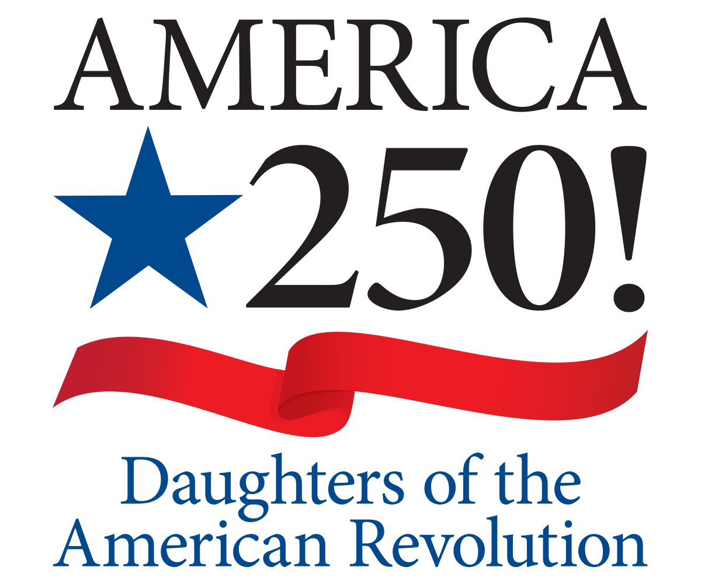
Proclamation
Offered by the National Society Daughters of the American Revolution

WHEREAS; On July 4, 2026, our nation will commemorate the Semiquincentennial anniversary of the signing of the Declaration of Independence; and
WHEREAS; The journey toward this historic milestone is an opportunity to reflect on our nation's past, honor the contributions of all Americans, and look ahead to the future generations who will carry forward the ideals of democracy and individual liberty that make the United States a unique nation in the world community; and
WHEREAS; The great state of Michigan was founded by the Revolutionary War generation and their children, pressing west into the territory organized by the Northwest Ordinance into the Northwest territory, which was land ceded by Britain to the United States by the Treaty of Paris of 1783; and the State of Michigan; and
WHEREAS; The National Society Daughters of the American Revolution (DAR) is a non-political women's service organization, established in 1890, whose members are lineally descended from Patriots of the American Revolution; and
WHEREAS; Through the President General's leadership, all Daughters are spending the next three years illuminating Our Legacy by celebrating our nation's rich history and diversity, promoting belonging through membership and dedicated service to God, Home, and Country, and by completing projects in unique, local and impactful ways; and
WHEREAS; From the 250th anniversary of the Boston Tea Paty in 2023 until the 250th anniversary of the signing if the treaty of Paris in 2033, Daughters are celebrating our nation's rich history and diversity of experience by honoring all men and women who achieved American independence. These Patriots, believing in the noble cause of liberty, fought valiantly to establish a new nation.
IN TESTIMONY WHEREOF, I, Judith L. Dorr Van Poperin, by virtue of the authority vested in me as America 250! Chair of the Sarah Treat Prudden Chapter NSDAR, in the City of Jackson, State of Michigan, have hereunto set my hand to be affixed this 10th day of April, in the year two thousand twenty-six.

Signed:_________________________________

